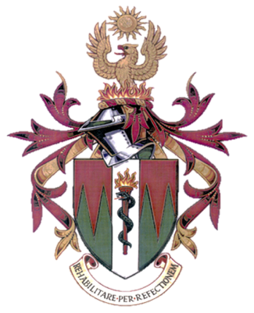

IMPT Congress Manchester 2023

Feedback Survey

Please email form to
imptwebinars@gmail.com

1. What percentage of the information was new to you at this IMPT Congress -Manchester 2023?

2. Would you like to learn more about the topics presented and if so, what topics would you like to know more about?
Yes/No

3. Please rate the speaker's knowledge of the topic and their presentation skills?
1: Poor and 10 Excellent

Session 1; Theme Education
-Keith Winwood. Importance of Research and Education in Reconstructive Science
/10
-Hitesh Koria. Alternative Entry Routes Update (IMPT Education Committee)
/10
-Nick Connolly. IMPT Lead Trainers Update
/10

Session 2; Theme Research & Innovation
-Key Note Speaker - Professor Julian Yates
Title: The Digital World in Dentistry and Oral & Maxillofacial Surgery
/10
-Stephanie Ramsurrun- Reconstructive Scientist
Title: Influence of Pore Geometry on Mechanical Properties for 3D Polymer Tissue Engineering Scaffolds - Project results
/10

-Sara Guerrero-Appleford - Reconstructive Scientist
Title: 3D-Printed Calcium Phosphate and Zirconium Dioxide Cements with potentials for bone tissue engineering and reconstructions
/10

Session 3; Theme Research & Innovation
-Key Note Speaker- Professor Moi Hoon Yap
Title: Computer Vision in Skin Assessment and Facial Inpainting
/10
-Katie Spooner- Maxillofacial Prosthetist
Title: Alternative Technique for Fabricating an interim Nasal Profile dressing -The Leicester Technique
/10
-Poppy Taylor Crawford - Maxillofacial Prosthetist
Title: Developing a technique aided by 3D imaging, design and printing for fabrication of large / complex silicone foam contour prosthesis
/10
-Shivani Lakhanpal- Trainee Reconstructive Scientist
Title: Is the Pursuit of Anatomical & Aesthetic Human Form Important to Facial Prosthetic Patients?
/10

Session 4; Theme Research & Innovation
-Amy Davey- Principal Reconstructive Scientist
Title: My Doctorate Experience and Research so far
/10
-Jordan Abbasi- Reconstructive Scientist
Title: Custom-made Spacers for Temporomandibular Joint Resection
/10
-Oliver Burley- Principal Reconstructive Scientist
Title: (Tbc)
/10
-Chris Maryan- Education Guru & Principal Recruiter to the Profession
Title: Who's in charge
/10

4. What new knowledge have you gained from the IMPT Congress Manchester 2023? *

5. Please confirm your full name and email address to send your IMPT Congress Manchester certificate to below.

